University of the People

CS3307 Operating System 2

Unit 3 Written Assignment 3

Anonymous Student

**Introduction**

The Linux file system is a crucial aspect of the operating system, providing a structured way of organizing files and directories. This document aims to explain the principles, functions, and examples of the Linux file system and the role and function it plays in the operating system(*Linux Filesystem Hierarchy*, n.d.).

**Principles of the Linux File System**

The Linux file system follows a hierarchical structure, with the root directory ("/") at the top. All files and directories are organized under this root directory in a tree-like structure. The file system is case-sensitive and uses forward slashes to separate directories(*Linux Filesystem Hierarchy*, n.d.).

**Functions of the Linux File System**

According to (*Linux Filesystem Hierarchy*, n.d.) The Linux file system provides several functions, including:

* File Organization: The Linux file system provides a structured way of organizing files and directories, making it easy to navigate and find specific files.
* Security: The file system provides permissions for files and directories, allowing users to control access to their files and folders.
* File System Maintenance: The file system provides tools for managing and maintaining the file system, including disk usage and file backups.

**Some common commands**

* cd: change the current directory
* ls: list the files and directories in the current directory
* mkdir: create a new directory
* rm: remove a file or directory
* mv: move or rename a file or directory
* cp: copy a file or directory e common commands

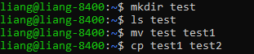 

**Examples of Linux File Systems**

Some of the most common directories in the Linux file system include:

/bin: Contains binary files, such as system utilities and applications.

/etc: Contains configuration files for the system and applications.

/home: Contains user home directories.

/var: Contains variable files, such as log files and databases.



**Role and Function of the Linux File System**

According to (*Linux Filesystem Hierarchy*, n.d.) The role of the Linux file system is to provide a way to store and organize files in a hierarchical structure. It also provides a way to manage permissions on files and directories, mount and unmount other file systems, and provide a virtual file system to access system resources. The function of the file system is to provide a way for users to interact with the operating system and manage files and directories.

**Prompts**

According to (*The Linux System Administrator’s Guide*, n.d.), A prompt is a command line interface that is used to interact with the operating system. The prompt displays the current working directory and provides a space for entering commands.

Some popular prompts in Unix/Linux operating systems include:

Bash: The default prompt for most Linux distributions.

Zsh: An alternative shell with advanced features.

Fish: A user-friendly shell with auto-completion and syntax highlighting.

**Key features of prompts:**

The prompt displays the current working directory.

The prompt provides a space for entering commands.

The prompt can be customized to display additional information such as username, hostname, or git branch.



The structure of the prompt is as below:

**username@hostname:/path$.** The home directories are shown as the ~ like



**RPC Introduction**

According to Birrell and Nelson (1984), Remote Procedure Call (RPC) is a communication protocol that enables clients to invoke procedures on servers that are located on remote machines, as if they were local to the client. RPC can be used in a distributed system to provide a simple way for applications to call procedures or functions located on other machines. The basic idea behind RPC is to provide a mechanism for the client to call a function or procedure on a remote server, without having to know the details of how the call is transmitted or how the result is returned.

RPC works by serializing the parameters of the function call into a message and sending it over the network to the server. The server deserializes the message and executes the requested function or procedure, then serializes the result and sends it back to the client. RPC abstracts away the details of network communication, allowing developers to focus on writing the application logic without having to worry about the complexities of network programming.

A simple RPC server and client implementation are as below:

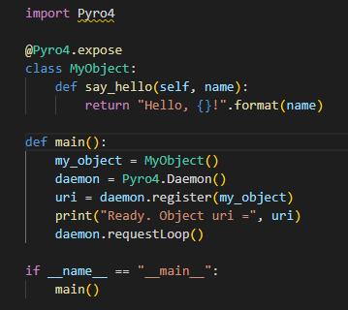



The server is hosting to localhost:57262

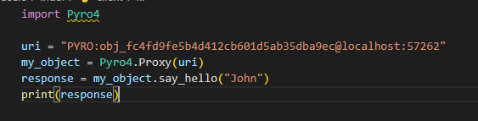

The client then invokes the RPC call with Uri.



The response is generated.

**Security in Linux system**

Security is a critical aspect of Linux systems, and it includes several features to protect the system against various types of attacks. One of the primary security features is user authentication, which ensures that only authorized users can access the system. Linux systems use passwords or other forms of authentication, such as biometrics, to authenticate users. For example, the passwd command is used to change a user's password in Linux (Parker, 2018).

Another essential security feature in Linux is encryption, which helps to protect data on the system from unauthorized access. Linux supports various encryption technologies, including disk encryption and file-level encryption. For instance, the dm-crypt module is used to encrypt disks and partitions in Linux (Babun, 2018).

Authorization is another security feature in Linux that determines what actions users can perform on the system. The system administrator can set up access control policies that restrict access to specific files or directories. For example, the chmod command is used to set permissions on files and directories in Linux (Parker, 2018).

Linux also includes several security tools that help to monitor and protect the system against attacks. For example, the auditd tool is used to monitor system events, and the iptables firewall is used to restrict network access to the system. Additionally, Linux has a robust system of software repositories that ensures that users can install software safely from trusted sources (Babun, 2018).

**Conclusion**

In summary, the Linux file system is a hierarchical structure that provides a structured way of organizing files and directories. It offers several functions, including file organization, security, and file system maintenance. The file system plays a critical role in the operating system, enabling users to manage and control access to their files and folders, and providing tools for managing and maintaining the file system. And,

Linux has several security features, including user authentication, encryption, authorization, and security tools that work together to protect the system against svarious types of attacks.

**Reference**

Linux Documentation Project. (2022). Linux file system hierarchy. Retrieved from http://www.tldp.org/LDP/Linux-Filesystem-Hierarchy/html/index.html

Birrell, A. D., & Nelson, B. J. (1984). Implementing remote procedure calls. ACM Transactions on Computer Systems (TOCS), 2(1), 39-59. doi: 10.1145/357401.357404

Babun, L. (2018). Linux Security. Packt Publishing Ltd.

Parker, R. (2018). Linux Bible. Wiley.